4/10/2020

Kartik Sojitra

100723768

Status Report

Enterprise Reporting Solution

**Table of Contents**

Overview 2

Project Goals and Objective 2

Project Benefits 4

Project Approach 5

Assumptions 7

Constraints 7

**Figures**

**Figure 1- End to End TRAIS/GHGIS Solution 3**

**Figure 2– High level data flow for each of the TRAIS & GHGIS solutions 4**

**Figure 3 - Incremental Life cycle model for software development 6**

**Figure 4 - High-level Budget 7**

# Overview

The reporting system design by the ministry of the environment in Alberta to accomplished various task of two different datasets. This system collect data from Toxics Reporting and Information System (TRAIS) and Greenhouse Gas Information System (GHGIS) individually but process it using the same infrastructure. The environmental branch was approved 1.7 million to achieve the objective.

The extent of the task is characterized as Utilizing the existing IT and Reporting Foundation to run out the TRAIS/GHGIS announcing system. Actualize new undertaking detailing devices. Collaborate with the Ministry of Environment to gather the information from the different associations ordered to report toxics and ozone harming substance emanations into the air. Construct an answer utilizing web administrations to catch and change information. Assemble Adhoc and canned reports. Make reports accessible inner gatherings and outer to people in general.

This project would obtain a merchant group to finish most of the improvement work and to make the engineering documentation expected to get past an administration procedure and to keep up the arrangement. This merchant group would be bolstered by inner full-time specialized staff, and where their staff holes, expense for administration experts would be employed to fill those holes.

This contextual investigation gives the fundamental subtleties a project administrator would need to assemble the joining venture plan and to build up the basic task procedures to deal with the execution of the undertaking.

**1) Toxics Reporting and Information System**

In the year 2008, the MOE propelled its toxics to decrease the system. The system expected to lessen contamination and educate Albertans about harmful synthetic substances noticeable all around, water, land and purchaser items. The Air Toxics Management Program gave the structure to the procedure.

**2) Greenhouse Gas Information System**

The Alberta reported its Carbon and Greenhouse Gas enactment to support battle environmental change and construct a more grounded, progressively serious, low-carbon economy in the year of 2007.

# Project Goals and Objective

The Air Toxics Management Program gave the structure to the methodology. The methodology intended to decrease contamination and illuminate Albertans about lethal synthetic substances noticeable all around, water, land and shopper items. The Air Toxics Management Program concentrated on open straightforwardness and expanding attention to the utilization and arrival of poisons in the area. The program was centered around open straightforwardness and expanding ' attention to the utilization and arrival of poisons in the area, in trusts this would spur the business to move past the obligatory toxics decrease arranging prerequisites into the willful usage of these toxins decrease plans. The program requires the announcing of some office explicit toxics-related data out to the general population.

A data the board and data innovation system are required to gather, oversee, and encourage writing about data gathered under the program. Alberta This structure will be the basic system by which offices will meet the new necessities to present the data about the toxics they utilize and make to the MOE, just as their toxics decrease plans. It will likewise be the component by which the Alberta government will help citizens to get educated about toxics in the territory's networks. As it were, the achievement of the toxics decrease technique eventually depends on the advancement and execution of this structure (TRAIS).

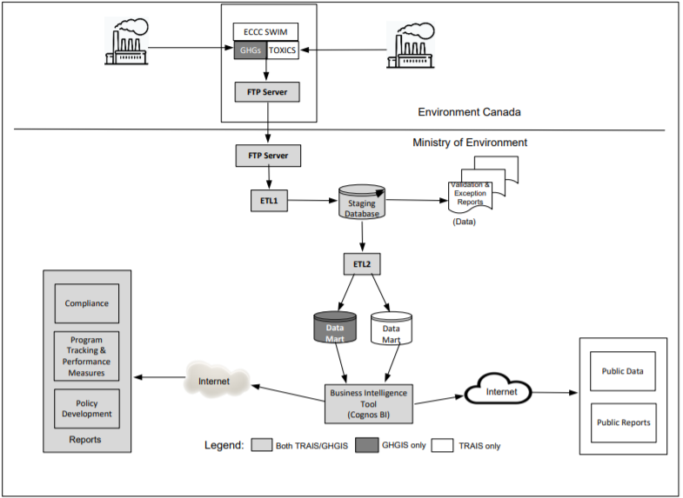

Figure 1- End to End TRAIS/GHGIS Solution

The Alberta reported its Carbon and Greenhouse Gas enactment to support battle environmental change and fabricate a more grounded, progressively serious, low-carbon economy. This enactment requires offices in the power age division, fabricating parts, and enormous business and institutional vitality clients to inform their ozone-depleting substance ("GHG") emanations. The company's need for this activity centers around the improvement of a data innovation framework to help the controlled prerequisites of the Carbon and Greenhouse Gas Emissions Reporting Legislation Alberta. The MOE has confirmed that it might want to reuse ECCC's SWIM framework to gather information from directed offices as required by the Alberta enactment.

The Environment Canada and Climate Change (ECCC), Single Window Information System (SWIM) is an internet declaring interface utilized by the central government to help its National Pollutant Release Inventory. The Single Window Information System will be utilized by offices as the announcing interface for TRAIS that will empower the offices directed under the Alberta program Alberta to inform their toxics-related information to the MOE government. This methodology would limit the announcing trouble on industry, as any commonly needed information is as of now being accounted for into SWIM by these offices as compulsory data for the National Pollutant Release Inventory.

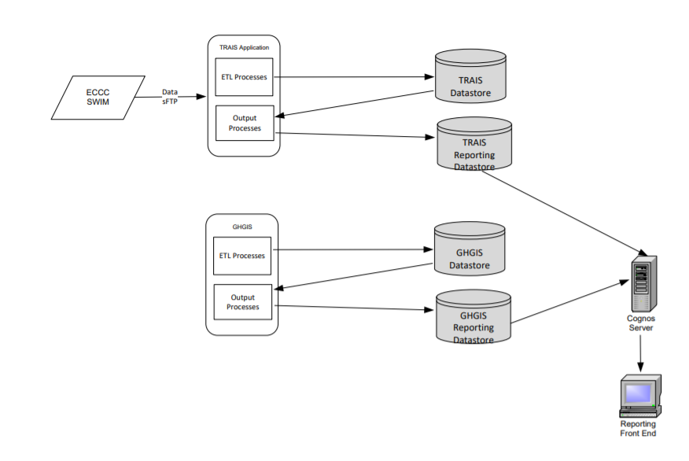

Figure 2– High level data flow for each of the TRAIS & GHGIS solutions

# Project Benefits

One of the significant advantages that get from these frameworks is to decrement in natural unsafe materials. In the wake of applying this venture into the Alberta region, most of the organizations diminished their unsafe compound use and lessening their carbon economy. The legislature of Alberta gave data about the task to the individuals and the mindfulness was expanded.

Moreover, numerous individuals halted the use of destructive concoction materials under this TRAIL framework. This framework is opened and straightforward for both the organization and the open eye. With the goal that everybody can realize what was happening in the framework. The approval and check work were finished by the EPB framework. Under this structure, the TRAIS did 36 routine statements and GHGIS did 21 official records. Every one of these reports help to foresee and decide the measure of contamination accessible. Each large task needs well-talented business, so considering this need, numerous great gifted individuals landed positions.

The above all else objective is to give an elevated level framework of TRAIS and GHGIS. Gathering the subsidizing measure of 1.7million from the Manager of the Environmental Management Branch. With these assets, the MOE can manufacture the TRAIS and GHGIS frameworks. Assembling all the needful information with the assistance of Environment Canada (EC) web-based detailing apparatuses. These apparatuses can replace all the different datasets and join every one of the information into one single report. Approve and check the entire information utilizing the FTP server. After identifying the missing qualities and mistakes, the MOE will fix the dataset by connecting it with the offices. Giving the information to the Data-shop and offer access to the MOE's information supervisory group through the Cognos server. The last and most vital goal is to with the assistance of every one of these experiences’ full information, reduce the synthetic substance and carbon quantity from the earth. Creating open mindfulness from this will be an extra goal.

# **Project Approach**

The TRAIS/GHGIS project holds a very different approach. The requirements for this project can be divided into further smaller modules in order to make the project run smoothly. Hence, the approach that will be best suited for this project would be the**Incremental life cycle model**. A practical version of the software would be produced through the first module, so we have working software in an early phase of the project life cycle. With every subsequent release of the module, it adds function to the previous release. The process continues until the final result is attained. This model will provide assistance to the IT team to perform the tasks efficiently, for which the stakeholders would provide them with the primary requirements. As this project will be continued for a long time, there are chances that different requirements may arise, or stakeholders might demand some changes to which the IT team can perform iterations to reach for the product.

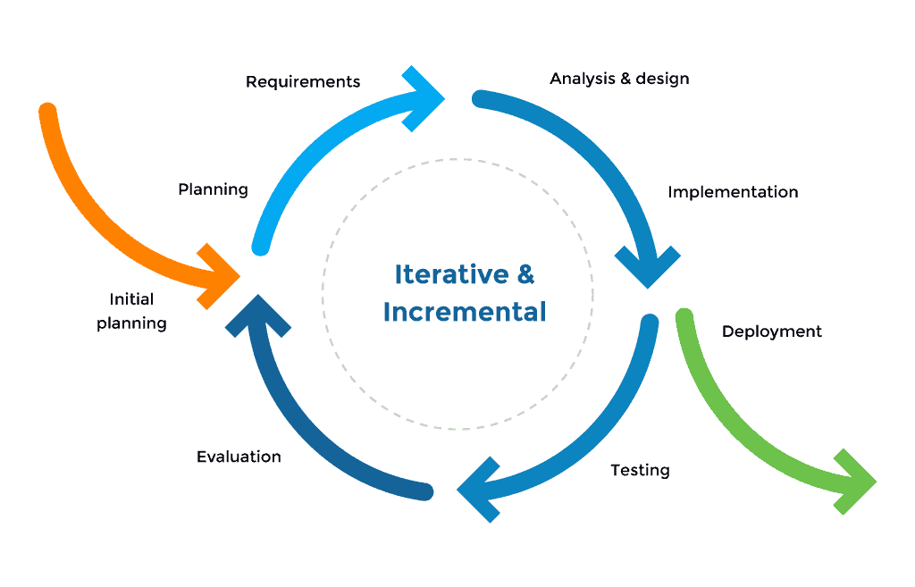

Figure 3 - Incremental Life cycle model for software development

Stephanie Gill being the Project Manager and the subject matter expert in the TRAIS project. He hired a team prior to the commencement of the project, The Cognos Reporting Solution was procured and implemented 6 months before and the team is lacking the skills required for operating. Hence, it can be advised that the team gains adequate training for using the software.

The contract with the Cognos expert is also about to expire for which a solution needs to be taken in order to successfully deliver the TRAIS/GHGIS project. Based on the information provided it is certain that due to the high-level budget allocated for the project the approach is very much suitable in order to control the cost before releasing the final solution. The budget of 1.7M is approved by the Environmental Management Branch. In the project's banking record, every department is defined with pricing specifications. The wages of all employees are on an hourly basis. A total of 4 work packages are presented that has large investment requirement. Furthermore, BI and BA consultants and team analysts also have several budget needs. The budget can further be classified as,

|  |  |
| --- | --- |
| Resources | Budget |
| Requirements Analysis and Documentation | $200K |
| Inbound ETL | $85K |
| Reporting ETL | $295K |
| System Documentation | $90K |
| BI Consultant | $195K |
| BA Consultant | $110K |
| QA Analyst | $150K |
| Project Manager | $65 |
| Data Modeler | $70 |
| Database Administrator | $55 |
| Solution Designer | $65 |
| Systems Analyst/Middleware | $55 |
| Architect | $70 |
| FTE server | $35K |
| SFTP site | $6K |
| first monthly hosting charge | $8K |

Figure 4 - High-level Budget

# Assumptions

1. Training of the team members will be completed on time for successful completion of the project.
2. The contractor for Cognos solutions would be retained in a set timeframe.
3. The project will be completed within the allotted Budget.

# Constraints

1. Completion of the project in the required timeline.
2. The project needs to be completed using limited resources.
3. The project needs to be completed as per the stakeholder’s requirements.